SQL Server

Connection to SSMS (SQL Server Management Studio)

SSMS and SQL Server both are different.

SSMS (SQL Server Management Studio)

SSMS is client tool used to connect or communicate with SQL server (Database Server). It is not the server by itself. We connect SSMS to database server by specify server’s configuration in it.

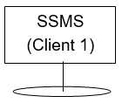



Database Server

Object Explorer in SSMS

Object explorer shows all SQL server objects.

SQL server objects are:

1. Database
2. Trigger
3. Stored Procedure
4. Functions
5. View

Open Object Explorer: -

View -> Object Explorer

System Databases:

These databases installed automatically at the time of installation of SSMS. These are required for the functionality of the SSMS.

System Databases are:

1. master
2. model
3. msdb
4. tempdb

Database

Database is sql server object.

Create Database:

Create database <DatabaseName>

When we create a database, two types of files get generated automatically (i.e., every database creation weather system/user define database, two files get automatically generated). These two files are:

1. <DatabaseName>.mdf

This file contains actual data.

1. <DatabaseName>.ldf

This file contains transaction log file. It is used to recover database.

**Steps to view these files:**

Right click Database > Properties > Files Tab > Path

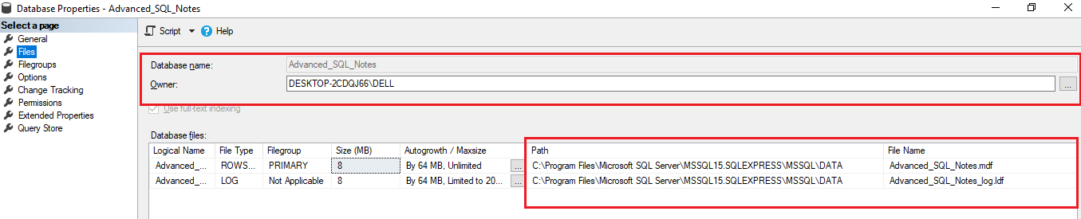

Drop Database:

Drop database <DatabaseName>

Dropping a database, deletes the .ldf and .mdf files behind the scenes.

We can’t drop a database if it is currently in use.

So, if other users are connected, we should put database in single user mode and then drop it.

Set Database at single user mode

Alter database <DatabaseName>

Set single_user with Rollback immediate

“With Rollback Immediate” command, SQL Server will rollback all incomplete transactions and connection to the database.

**Note:**

We can’t drop system databases.

Renaming Database:

1. Alter Database <OldDatabaseName>

Modify Name=<newDBName>

1. execute sp_rename <oldDBName> <newDBName>

Table

Creating Table & enforce primary key, Unique Key ,Foreign Key constraints, check constraint, default constraint:

Create table <TableName>

(

[ColumnName1] <columnDataType><lengthOfCharacters> [<nullability constraint>],

[ColumnName2] <columnDataType><lengthOfCharacters> [<nullability constraint>]

Constraint <df_ConstraintName> default (<defaultValue>),

Constraint <PK_ConstraintName> **Primary Key** ([colName1][,colName2],…),

Constraint <UQ_ConstraintName> **Unique** ([colName1][,colName2],…),

Constraint <FK_ConstraintName> **Foreign Key** (FK_ColumnName1)

References <TableNameWhichIsToRefer>(PrimaryKeyColumnName),

Constraint <ck_constriantName> **Check** (<ConditionReturnsTrueOrFalse>),

~~Constraint <df_constriantName>~~ **~~Default~~** ~~(DefaultValue) for <columnName>~~

)

Nullability Constraint:

Two nullability constraint:

1. null
2. not null

Key Points

1. If column name contains spaces then enclose column name inside [ ],

otherwise, no need to enclosed in [ ].

1. If we don’t specify nullability constraint then it will be ‘null’ by default.
2. The foreign key should refer to the primary key column of another table.
3. We can define default constraint inline only.

If we define default constraint like strikethrough statement then Error.

Example:

Bank (Account Number, Bank Name, IFSC)

Employee (Employee Id, Employee Name, Father Name, Aadhar, BankAccount)



Rename Table

sp_rename ‘OldTableName’, ‘NewTableName’

Alter Table

Adding column to Table

Alter table <tableName>

# Adding Column to existing table

Add <columnName1> datatype <nullability>,

<columnName2> datatype <nullability>,

<columnName3> int identity(1,1) <nullability>,

<columnName4> datatype <nullability> default (‘’)

**Note: No need to specify multiple ‘add’ multiple times while adding multiple columns.**

Changing Data type of the column

Alter table <tableName>

Alter column <columnName> newDataTpe nullability

**Note:**

If warning message displays on altering table, then go to:

Tools > Options > Designers > Table & DB Designer

Disable > prevent saving changes that require recreation

Changing Only Column Name and Rest things should be same

?